Apple Sales Project Analysis using SQL.
Solving a Business Problem. Generate a report to get an overview of the project, even insight and trends, using descriptive analysis and Exploratory Data analysis.
Q1. Find the number of stores in each country:
SELECT COUNT (*) AS Number_of_Stores, Country
FROM Stores_
GROUP BY Country
ORDER BY COUNT(*) DESC
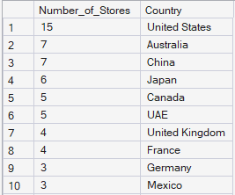
I’ve leveraged the total count of the table to retrieve the Highest number of stores. Later, GROUP BY Country assigned the value to their respective country, and the results displayed the highest number of stores all over the world. First, the United States has the highest number of stores, followed by Australia, China, and Japan.
Q2. Calculate the total number of units sold by each store.
SELECT SUM(s.quantity) AS Number_of_Units,
t.Store_Name, t.city FROM Sales_ s
JOIN Stores_ t ON t.Store_ID = s.Store_id
GROUP BY t.Store_Name, t.city
ORDER BY SUM(s.quantity) desc
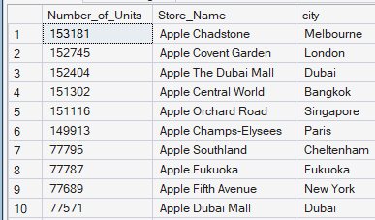
Here I’m trying to solve a problem to identify the Total Number of units sold by each Store. I’ve retrieved the data merge it, and later applied the JOIN function; the result has populated SUM as the total number of Units. GROUP BY their Store name and city, and ORDER BY DESC for the Highest units. So, The Result shows that the “City of Melbourne Apple Chadstone” has sold the Highest number of units in the whole world, followed by the store in London and Dubai. The recommendations to the business are to add more supplies to the TOP 5 stores in the world and increase business compared to other stores.
Q3. Identify how many sales occurred in December 2023.
SELECT COUNT(sale_id) AS total_sales
FROM Sales_
WHERE FORMAT (Sale_date, 'yyyy-MM') = '2023-12'
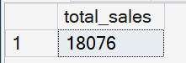
Pulling the total sales in December 2023. The specific month’s sales is a business problem. I generated the number of sales, 18076, which is the value recorded in December 2023. I’ve apply Count function of a sale_id and Where Clause to filter it for the December month.This concludes the number of sales that record the month of December; there is no analysis or comparison with other months.
Q4. Determine how many stores have never had a warranty claim filed.
SELECT Store_Name,
COUNT(Claim_id) as Number_of_Claim
FROM(
SELECT t.Store_ID, t.Store_Name, w.Claim_id
FROM Stores_ t
LEFT JOIN Sales_ s
ON t.Store_ID = s.Store_id
LEFT JOIN warranty_ w
ON w.Sale_id = s.sale_id)t
WHERE Claim_id IS NULL
GROUP BY Store_Name
This Query was to identify how many stores have never had a warranty Claim filed. I have JOIN three Table to identify this issue. Create a Subquery upon the JOIN query on the outer query I’ve leveraged the COUNT function for claim_id and the WHERE function to retrieve only records which is NULL (NULL values are those which have never had a warranty claim. The result is 69 Stores which haven’t registered for any single Warranty claim. My Conclusion, Company should attempt to notice about the Location of these stores and compare their sales of the product with the competitor.

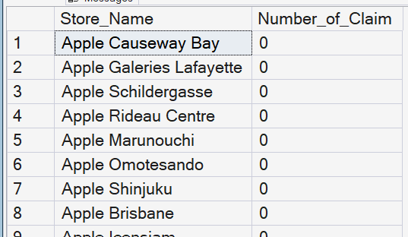

Q5. Calculate the percentage of warranty claims marked as "REJECTED"
SELECT
CONCAT(COUNT(claim_id) * 100 /(SELECT COUNT(*)FROM warranty_ ),'%') AS Percentage_of_Rejected
FROM warranty_
WHERE repair_status = 'Rejected'
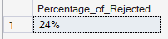
This query identifies the percentage of rejected warranty claims in the table. I’ve calculated the COUNT (Claim_id) multiplied by 100 and divided by the Total Count to retrieve the percentage of rejection. Include a WHERE clause to filter it only to the Rejected value in the table. The result presented above is a Screen shot around 24% rejected. The business should act to re-verify the case of rejected and make sure to complete this thing.
Q6. Identify which store had the highest total units sold in the last year.
SELECT TOP 1
t.Store_Name,
SUM(s.quantity) AS total_units,
YEAR(GETDATE()) - 2 AS previous_year
FROM stores_ t
JOIN sales_ s
ON t.Store_ID = s.Store_id
WHERE DATEPART(year,s.Sale_date) = YEAR(GETDATE()) - 2
GROUP BY t.Store_Name
ORDER BY SUM(s.quantity) DESC
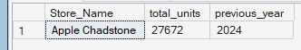
To find out the highest units sold in the last year, I’ve leveraged the current year to calculate the last has the data contains max 2024 data as the present year being 2026. So, I need to subtract 2 years to get the previous year of the record. Total units sold is the SUM of the quantity. I’ve retrieved the year from DATEPART and the current year using GETDATE (). I’ve done a join between the two tables. Here are the results: the Highest total units “27672” sold at the “Apple Chadstone Store” in the year “2024”. The business has to identify the other stores that can help supply more and offer great deals.
Q7. Count the number of unique products sold in the last year
SELECT COUNT(DISTINCT p.Product_ID) AS UniqueProducts,
SUM(s.quantity) AS Total_Products_Sold,
YEAR(GETDATE()) - 2 AS Year_
FROM Products_ p
JOIN Sales_ s
ON p.Product_ID = s.Product_id
WHERE DATEPART(YEAR, s.Sale_date) = YEAR(GETDATE()) - 2
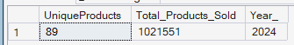
This query identifies the unique products sold in the last year and retrieves the count of them. Calculate the sum of the quantity and count of the unique products. Implement the JOIN function to extract two table and, merge it and sort it by WHERE clause for DATEPART for the specific year from the columns. The query concludes that 89 unique products were sold last year.
Q8. Find the Average price of products in each category
SELECT
c.category_id,
c.category_name,
AVG(p.Price) as avg_price
FROM Products_ p
JOIN Category_ c
ON p.Category_ID = c.category_id
GROUP BY c.category_id,
c.category_name
ORDER BY AVG(p.Price) desc
This query calculates the average price of products in each category. It reveals that the top tablet Average price is 1479, followed by the laptop average price 1194. Solved this problem JOIN function and Avg aggregate of price.
Q9. How many warranty claims were filed in May?
SELECT
COUNT(*) AS Month_of_May
FROM warranty_
WHERE DATEPART(MONTH,claim_date) = '05'
Identifying the warranty claims filed in the month of May. Calculated the Total Count of the table and filtered it with the WHERE function to extract the May month by DATEPART. Here is the final result: “2941” claims were filed in May.
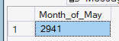
Q10.For Each Store, identify the best-selling day based on the highest quantity sold.
SELECT *
FROM( SELECT
Store_id,
SUM(quantity) AS Total_quantity,
DATENAME(WEEKDAY,Sale_date) AS Weekdays,
DENSE_RANK()OVER(PARTITION BY Store_id ORDER BY Store_id,SUM(quantity)) rank_
FROM Sales_
GROUP BY Store_id,DATENAME(WEEKDAY,Sale_date) )t
WHERE rank_ = 1

In my analysis, I identified the best-selling day according to Highest Quantity Sold. There are insights generated with query the Weekdays along with the store_ID and calculate the window function inner query, and assigns it a dense rank, sorted with a WHERE clause to retrieve the rank 1 value as the highest number of quantity sold. My opinion is that Store must start pulling customers on other days as well as the highest sold out days by adding more supplies on the store.

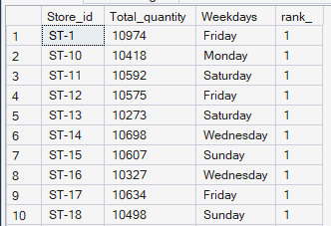
Q11. Identify the least selling product in each country for each year based on Total units sold.
SELECT *
FROM(
SELECT
t.Country,
SUM(s.quantity) AS Total_qty_Sold,
p.Product_Name,
RANK() OVER(PARTITION BY t.Country Order BY SUM(s.quantity)) as Rank_
--DATEPART(YEAR,s.Sale_date) AS YEAR_
--SUM(s.quantity) as total_quantity
FROM Sales_ s
JOIN Stores_ t
ON t.Store_ID = s.Store_id
JOIN Products_ p
ON p.Product_ID = s.Product_ID
GROUP BY t.Country,p.Product_Name
)t
WHERE Rank_ = 1
This query delivers the least-selling product in each country. I’ve calculated this query using the window function of rank over the country and ORDER BY the SUM of quantity to identify the rank. I joined three tables and GROUP BY the table later store this inner query using a subquery and an outer query; filter it with a WHERE clause and extract the row with RANK () = 1. The insight was found that each country is filtered with the lowest quantity sold, including the product name. My business recommendation is to avoid supplying this product to these countries.

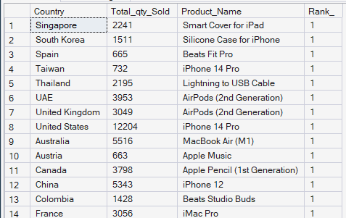
Q12. Calculate how many warrant claims were filed within 180 days of a product sale.
select w.*,
s.sale_date
FROM warranty_ w
LEFT JOIN sales_ s
ON s.sale_id = w.sale_id
WHERE
DATEDIFF(day, s.sale_date, w.claim_date) <= 180
In this question, it indicates how many warranty claims were filed within 180 days of product sale. They have ingested data from two tables to find the outcomes. To solve the problem, I have merge table using JOIN functions and sorted it out with WHERE functions, applying DATEDIFF functions sale of date subtracted Claim of date, which is less than 180, to present the data. The insights are registered that a total of ‘5,733’ claims were filed within 180 days of the product sale. The business recommends that the number of individual claims filed for warranty monitor issues be analyzed to determine whether there is any manufacturing defect or Customer fault.
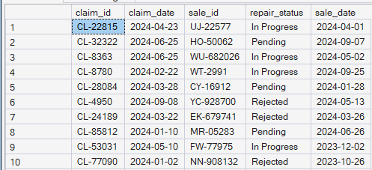
Q13. Determine how many warranty claims were filed for products launched in the last 2 years.
SELECT p.Product_Name,
COUNT(s.sale_id) AS Count_,
COUNT(w.claim_id) AS No_claim
FROM warranty_ w
RIGHT JOIN Sales_ s
ON w.Sale_id = s.sale_id
JOIN products_ p
ON p.Product_ID = s.product_id
WHERE p.Launch_Date >= DATEADD(YEAR, -2, GETDATE())
GROUP BY p.Product_Name
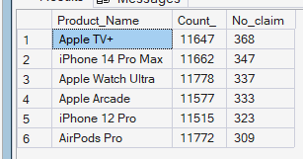
I’ve identified that warranty claims were filed for products launched in the last two years. Solving the problem through Count of Sale_id and COUNT of claim_id. I’ve analyzed three tables to find the result, filtering WHERE clause to extract the last years data. Here is the Insights only 5 Product which has filed many warranty claims for launching the products. Top one product Apple TV + which is 368 number of claims after launching the product. Followed by iPhone 14 Pro Max. My Business recommendation identify the product in detail.
Q14. List the months in the last three years when sales exceeded 5,000 units in the USA.
SELECT
SUM(s.quantity) AS Total_count,
FORMAT(s.sale_date,'yyyy,MM') AS Date_
FROM Sales_ s
JOIN Stores_ t
ON s.Store_id = t.Store_ID
WHERE
t.Country = 'United States' AND
s.sale_date >= DATEADD(year, -3, GETDATE())
GROUP BY FORMAT(s.sale_date,'yyyy,MM')
HAVING SUM(s.quantity) > 5000
ORDER BY FORMAT(s.sale_date,'yyyy,MM')
The Analysis identified the months listed in the last three years where sales more than 5000 units in ‘USA’. Among these three years of sales, there were 17 months in total that recorded the exceeded 5000 units. The higher number of 21046 in the month of December,2023 indicate the increase in potential quality concerns, or a larger customer base. These findings suggest that the business should sell products and perform best in various months through launching new offers, Software updates, and customer engagement.
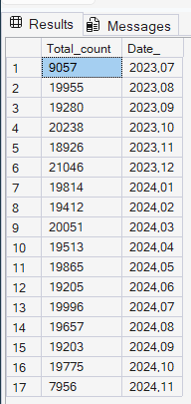
Q15. Identify the product category with the most warranty claims filed in the last three years.
SELECT
c.Category_name,
COUNT(w.claim_id) AS No_of_Claims,
DATEPART(YEAR,w.Claim_date) AS years
FROM warranty_ w
LEFT JOIN sales_ s
ON w.sale_id = s.sale_id
JOIN products_ p
ON p.Product_ID = s.product_id
JOIN category_ c
ON c.category_id = p.Category_ID
WHERE DATEPART(YEAR,w.Claim_date) >= YEAR(GETDATE ()) - 3
GROUP BY c.category_name,DATEPART(YEAR,w.Claim_date)
ORDER BY COUNT(w.claim_id) DESC

I analyzed the most warranty claims filed in the last three years by the product category. This result shows that the higher warranty claims has been filed for the Accessories categories over ‘4650’ number of claims in the year 2024, followed by the Smartphone and 8 other categories. Calculated this SUM by merging four tables and implementing a WHERE Clause and GROUP BY. These findings suggest that businesses verify the claims, resolve the problem, and identify the reason that causes the product these could manufacture detect, technical issues, and false claims.
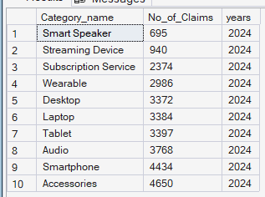
Q16. Determine the percentage chance of receiving warranty claims after each purchase for each country.
SELECT
t.Country,
Total_unit_sold,
No_of_Count,
CAST((No_of_Count * 100.0 /Total_unit_sold) AS DECIMAL(10,2)) AS Percentage_
FROM (
SELECT
t.Country,
SUM(s.quantity) AS Total_unit_sold,
COUNT(w.claim_id) AS No_of_Count
FROM sales_ s
JOIN stores_ t
ON s.store_id = t.Store_ID
LEFT JOIN warranty_ w
ON w.Sale_id = s.sale_id
GROUP BY t.Country
)t
ORDER BY CAST((No_of_Count * 100.0 /Total_unit_sold) AS DECIMAL(10,2)) DESC

This query identifies the percentage of warranty claims after purchase for each country. Among these countries, the highest percentage of warranty claims is over 0.59%, assigned to the country Austria, followed by the Netherlands. The solution to this problem will be to re-verify these countries, following up the manufacturing-to-retail process, and determine whether there are any kind of activities. This can reduce warranty claims due to false information. Later, identify the problem of claims in these countries, validate through the manufacturing step, and improve the quality of the product.
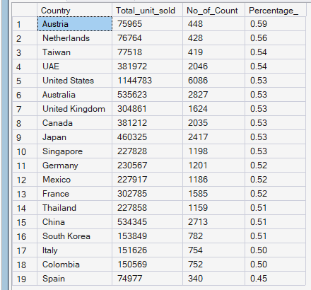

Q17. Analyze the year-by-year growth ratio for each store.
WITH Previous_year as
( SELECT
t.Store_ID,
t.Store_Name AS Store_name,
FORMAT(s.sale_date,'yyyy') AS YEAR_,
SUM(s.quantity * p.Price) AS total_sales
FROM stores_ t
JOIN Sales_ s
ON t.Store_ID = s.store_id
JOIN products_ p
ON p.Product_ID = s.product_id
GROUP BY t.Store_Name,
FORMAT(s.sale_date,'yyyy'),t.Store_ID
),
table_2 AS (
SELECT
Store_Name,
YEAR_,
total_sales,
LAG(total_sales) OVER(PARTITION BY Store_Name ORDER BY YEAR_ ) AS Previous_sales
FROM Previous_year
)
SELECT
Store_Name,
YEAR_,
total_sales,
Previous_sales,
CAST(((total_sales - Previous_sales)* 100.0) / Previous_sales AS DECIMAL(10,2))AS YoY
FROM table_2
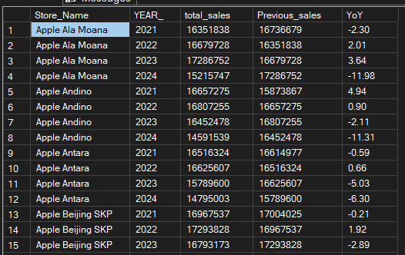
I’ve leveraged the query to identify the year-by-year growth for each store on the present table. Among these solutions, I have found that the insights of each store's previous total sales and the gap between in a percentage format easy to identify. Writing down this query combines two tables, two CTEs, Window functions LAG for previous sales, and basic aggregations. My suggestion for this solution is that the outcomes are organization needs to look into each store and they year sales. The majority are still receiving negative sales after launching a new product every year.
Q18. Calculate the correlation between product price and warranty claims for products, segmented by price range.
SELECT
CASE WHEN p.price < 500 THEN 'Less Exp'
WHEN p.price BETWEEN 500 AND 1000 THEN 'Mid-Range'
ELSE 'High Exp'
END AS Price_segmentation,
COUNT(w.claim_id) AS Count_claims
FROM warranty_ w
LEFT JOIN sales_ s
ON s.sale_id = w.sale_id
JOIN products_ p
ON p.Product_ID = s.product_id
GROUP BY
CASE WHEN p.price < 500 THEN 'Less Exp'
WHEN p.price BETWEEN 500 AND 1000 THEN 'Mid-Range'
ELSE 'High Exp'
END
In this Analysis, I’ve calculated the price segment and Correlation between price and claims. Among these, the High Expensive product has recorded the highest warranty claims as ‘16790’, followed by Mid-range ‘8121’ and Less Expensive as ‘5089’. There’s a high chance of warranty claims for the expensive product. I’ve solved this question through CASE WHEN statements, JOIN, and simple aggregation. My suggestion for business improvement is to increase the product quantity, as it is charged at a higher rate. The business must investigate the hardware before departing from the manufacturer's units.
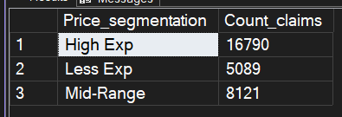

Q19. Identify the store with the highest percentage of "Completed" claims relative to total claims filed.

WITH Base_query AS
( SELECT
t.Store_ID,
w.repair_status,
COUNT(w.claim_id) AS Repaired_Completed
FROM warranty_ w
LEFT JOIN sales_ s
ON s.sale_id = w.sale_id
JOIN stores_ t
ON s.store_id = t.Store_ID
WHERE w.repair_status = 'Completed'
GROUP BY t.Store_ID,
w.repair_status
),
Base_query_2 AS
( SELECT
t.Store_ID,
COUNT(w.claim_id) AS Total_Repaired
FROM warranty_ w
LEFT JOIN sales_ s
ON s.sale_id = w.sale_id
JOIN stores_ t
ON s.store_id = t.Store_ID
GROUP BY t.Store_ID
)
SELECT
t1.Store_Name,
b1.Repaired_Completed,
b2.Total_Repaired,
CONCAT(CAST((b1.Repaired_Completed * 100 )/ b2.Total_Repaired AS DECIMAL (10,2)), '%') as Percentage_
FROM Base_query b1
JOIN Base_query_2 b2
ON b1.Store_ID = b2.Store_ID
JOIN stores_ t1
ON b1.Store_ID = t1.Store_ID
ORDER BY CONCAT(CAST((b1.Repaired_Completed * 100 )/ b2.Total_Repaired AS DECIMAL (10,2)), '%') DESC
In this query, I’ve identified the percentage of ‘Completed’ total claims filed and mentioned the store name itself. Among these findings, I analyzed the highest completed store, held at ‘Apple Mall of the Emirates’ of 30%, followed by ‘Apple Iconsiam’ as stands on same percentage, 30%. The least completed store, Apple Galleries Lafayette, has 19%, due to incomplete repairs as considered in this data. My business recommendation would be to follow up on the least listed store that has been unable to fulfill the customer request can affect sales and customer engagement.
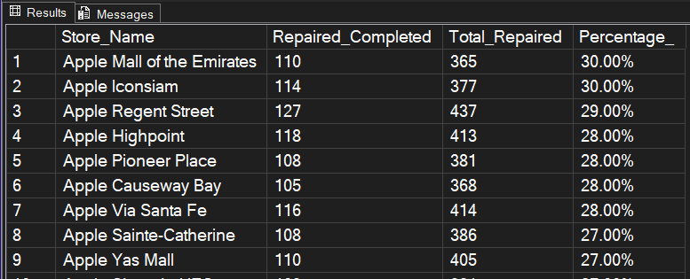

Q20. Write a query to calculate the monthly running total of sales for each store over the past four years and compare trends during this period.
SELECT
Store_,
year_,
Month_,
Total_sales,
SUM (Total_sales) OVER (PARTITION BY Store_ ORDER BY year_,Month_ ) AS running_sales
FROM (
SELECT
s.store_id as Store_,
YEAR(s.Sale_date) as year_,
MONTH(s.Sale_date) as Month_,
SUM(p.Price * s.quantity) AS Total_sales
FROM sales_ s
JOIN Products_ p
ON s.product_id = p.Product_ID
GROUP BY
s.store_id,YEAR(s.Sale_date),
MONTH(s.Sale_date)
)t
Writing a query, the data shows the running sales of each store increasing month by month, about 30%- 50% of the margin. It reveals that in this sector each store is making a profit each year from the last 4 years. The way to find the result of the running sales typically applies the Cumulative analysis Cumulative Measure by Dimension window function, and Subquery identified the problem in months. The business has grown its sales in the off-season period, which records lower compared to the seasonally adjusted.
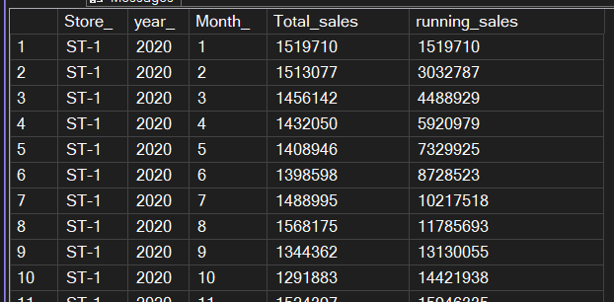

Q21. Analyze product sales trends over time, segmented into key periods: from the launch to 6 months, 6-12 months, 12-18 months, and beyond 18 months.
SELECT
p.Product_name,
CASE
WHEN s.Sale_date <= DATEADD(MONTH, 6, p.Launch_Date)
THEN '0-6 Months'
WHEN s.Sale_date <= DATEADD(MONTH, 12, p.Launch_Date)
THEN '6-12 Months'
WHEN s.Sale_date <= DATEADD(MONTH, 18, p.Launch_Date)
THEN '12-18 Months'
ELSE 'Beyond 18 Months'
END AS Period_,
SUM(s.quantity) AS total_sales
FROM sales_ s
JOIN Products_ p
ON s.Product_id = p.Product_ID
GROUP BY p.Product_name,
CASE
WHEN s.Sale_date <= DATEADD(MONTH, 6, p.Launch_Date)
THEN '0-6 Months'
WHEN s.Sale_date <= DATEADD(MONTH, 12, p.Launch_Date)
THEN '6-12 Months'
WHEN s.Sale_date <= DATEADD (MONTH, 18, p.Launch_Date)
THEN '12-18 Months'
ELSE 'Beyond 18 Months'
END
ORDER BY ProductName,
SUM(s.quantity)
In this Query, the data shows the product sales trends over time, with total units sold in the period between Launch to Sale date compare the increase in the period of time. The table below reveals more interesting details about sales that can easily be pulled by its product name. This Insight is meaningful stakeholder could and identifies product usage in the month it will be managed in the manufacturing unit. Businesses make their decisions based on this uncovered pattern, and my suggestion is a few products are being sold for more than 18 months, which has the potential to make more business.

